Writing into the Day
March 1st, 2017

Since this is our last “official” meeting of the WAC Academy, we are going to take some time to reflect on your experience: the activities we have engaged in, the topics we have written about, the ideas been thinking about or questioning, the discoveries we have made about ourselves...

Take a few minutes to read back through your Academy pre-writing, your daybook, your exit slips, our blog page (and the pictures on it), and other writing artifacts from the WAC Academy. Using open coding (or another methodological approach), identify emerging themes and other observations while considering what you have learned about yourself as a teacher, a writer, and a teacher of writing. (You can use the bottom of this page to take notes.) Use the chart on the back of this page to record your reflections.

As a teacher, I am… | As a writer, I am… | As a teacher of writing, I am…

Coding: Analyzing and Interpreting Data
Open Coding
- Read and skim through each of your sources. With a pen/pencil or on your computer, underline words, phrases, or sentences that stand out to you as expressing something about your topic’s major concepts. Remember, concept (or term) is a labeled section of data that a researcher identifies as significant to some facts that data represent. Concepts (or terms) are abstract representations of events, objects, actions or interactions and they allow researchers to group similar information to better understand the data.

- As we continue to create codes for new concepts, we should have more than few pages of codes. At that stage, we should analyze the codes to find the similarities and group them into categories (or themes) based on their common properties. The name of the category (or theme) can be different from the codes to express its scope better and if necessary, we can also create sub-categories from the codes then link to categories.
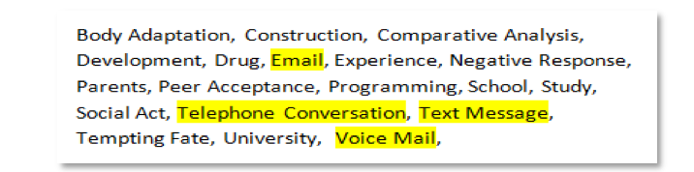
From the above set of codes, we can group the concepts: ‘Email’, ‘Telephone Conversation’, ‘Text message’ & ‘Voice Mail’ into a category and name it ‘Communication’.
Researchers often use highlights to distinguish categories (or themes). For example, you are coding a journal entry that constantly discusses the importance of context, each time the journal entry mentions context, or something related to context or situated writing, you would use the same color highlight. Context would become a concept, and other things related (types, etc.) would become categories – all highlighted the same color. Use different colored highlights to distinguish each broad concept and category. What you should have at the end of this stage are transcripts with 3-5 different colors in lots of highlighted text. I find it useful to transfer these into a brief outline, with concepts being main headings and categories being subheadings.

Another example provides an example of the relationship between major categories (themes) and associated concepts (or terms).
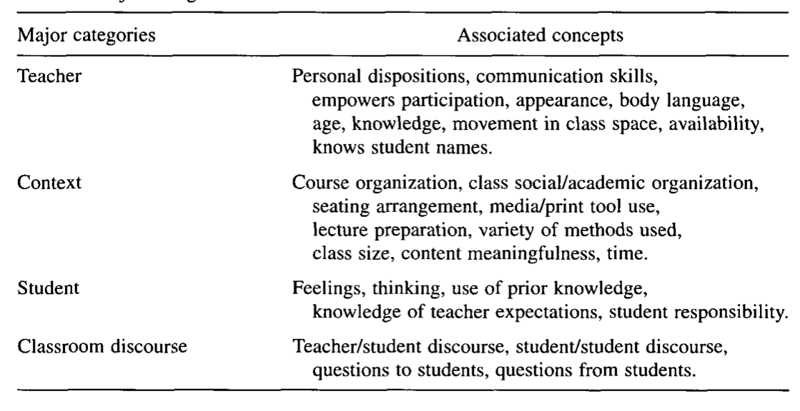
A sample set of major categories/themes and associated concepts/terms
Axial Coding
- In open coding, you were focused primarily on the text to define concepts and categories. In axial coding, you are using your concepts and categories while re-reading the text to 1. Confirm that your concepts and categories accurately represent interview responses and, 2. Explore how your concepts and categories are related. To examine the latter, you might ask, What conditions caused or influenced concepts and categories? What is/was the social/political context? or What are the associated effects or consequences?
For example, if one of your concepts is the audience, and two of your categories are primary audiences and secondary audiences, an axial code might be a phrase like, “It is important that writers are aware of audience, both primary and secondary, while attempting to communicate effectively.” Axial coding is merely a more directed approach at looking at the data, to help make sure that you have identified all-important aspects. Have your highlights ready for revision/addition.
On a separate document or sheet of paper, reflect on your observations about the results of your coding: What concepts (or themes) and terms did you notice? What idea(s) stood out to you? What do you think these results mean for each of individuals, the group as a whole, and/or your research question?
- We will follow up with a discussion on your findings. Be ready to share your results along with specific examples from your raw data.

